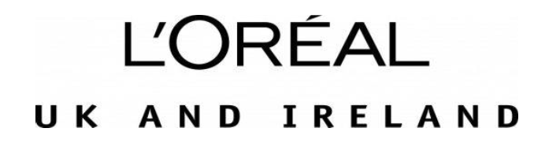

9th June 2023

The Nielsen letter dated 11th April 2023 shows a ranking table for serums within the Female Facial skincare market for United Kingdom (GB+NI), based on data for the 52-week period ending 25th March 2023. As per Tables 2 and 3 reproduced below, Garnier Vitamin C Anti-dark spot serum is ranked third in value and unit sales within the serum category (excluding private label).
The three serums that rank above Garnier Vitamin C Anti-dark spot serum in either value or unit sales – CeraVe Hydrating Hyaluronic Acid serum, The Ordinary Hyaluronic Acid 2% + B5 serum, and The Ordinary Niacinamide 10% + Zinc 1% serum – do not contain Vitamin C.
Therefore, we can filter the total market to only look at serums containing Vitamin C and can say Garnier Vitamin C Anti-Dark spot serum is the number 1 Vitamin C serum in the UK in value and unit sales.

TABLE 1: VITAMIN C SERUMS – VALUE RANKING
BRAND & PRODUCT | VALUE RANKING
GARNIER VITAMIN C ANTI-DARK SPOT SERUM | 1
L'OREAL REVITALIFT FILLER HYALURONIC ACID ANTI-WRINKLE SERUM | 2
LA ROCHE-POSAY PURE VITMN C10 ANT-WRNKL ANT-OXDNT RNVTNG SERUM | 3

TABLE 2: VITAMIN C SERUMS – UNIT RANKING
BRAND & PRODUCT | UNIT RANKING
GARNIER VITAMIN C ANTI-DARK SPOT SERUM | 1
L'OREAL REVITALIFT FILLER HYALURONIC ACID ANTI-WRINKLE SERUM | 2
SIMPLE VITAMIN C&E&F BOOSTER SERUM | 3

TABLE 3: TOTAL SERUMS
VARIANT | VALUE RANKING
CERA VE HYDRATING HYALURONIC ACID SERUM | 1
THE ORDINARY. HYALURONIC ACID 2% + B5 | 2
GARNIER VITAMIN C ANTI-DARK SPOT SERUM | 3
L'OREAL REVITALIFT FILLER HYALURONIC ACID ANTI-WRINKLE SERUM | 4
THE ORDINARY. NIACINAMIDE 10% & ZINC 1% | 5

TABLE 4: TOTAL SERUMS
VARIANT | UNITS RANKING
THE ORDINARY. NIACINAMIDE 10% & ZINC 1% | 1
THE ORDINARY. HYALURONIC ACID 2% + B5 | 2
GARNIER VITAMIN C ANTI-DARK SPOT SERUM | 3
OLAY ANTI WRINKLE FIRM & LIFT 2 IN 1 ANTIWRNKL BTR+ FRMG S | 4
CERA VE HYDRATING HYALURONIC ACID SERUM | 5

Source:
©2023 NielsenIQ value and unit sales, Female Facial Skincare, Serum category (client defined, excluding private label), variant, 52 w/e 25/03/23, United Kingdom (GB+NI) Total Coverage

